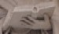 It’s Just Not Cricket!
October 2005
The sure way of knowing nothing about life is to try to make oneself useful.  ~Oscar Wilde | Impressions and Transitions  Autumn has recently arrived in Hackney. There are a few more dried leaves on the ground every morning, though I’m still waiting for that lovely smell of wet, rot, leaves and dirt hanging in the chilled air that makes fall my favorite season. I’m also craving cinnamon powdered donuts and apple cider, foods I don’t usually like but go perfectly with the season. I know for those of you in the Upper Peninsula the leaves changed and fell during August and September and you are now anticipating the first snow flakes of your six month long winter to arrive any day (I hear they’ve already visited Houghton!).  I’ve been in at Queensdown Road for almost two months now and to state the obvious, first impressions are not always correct. Some of my initial impressions of the service users and staff have had to be altered. My favorite change of opinion is about Peter.  When I received my placement for a residential home for adults with learning disabilities I went ‘No way!’ and took a while to read through all of the information sent to me. After a few read throughs on my own and then with other people I gradually adjusted to the idea and decided it was worth a try. I told myself ‘It’s only a year.’ I had the support of friends and family and understood the people I would be working with to be at a higher level of functioning considering their disabilities. My placement sheet said ‘…the house aims to help each resident to live as much of an independent life as possible. Eventually the resident will move out to their own accommodation….’ This idea has had to be modified as some of the residents can’t even be given a key to the front door because they may run out of the house placing themselves and others at risk.  Peter is in part representative of the reason for my first reaction. He has a vocabulary of about twenty words, cannot fix his own meals or cup of tea, and likes to take toilet paper out of the bathroom, wad and tear it up and toss it on the floor. I have had the privilege over the last few weeks to see beyond these and other unpleasantries of the surface to the sweet man underneath. Some of my favorite times on the job have been helping him up the front stairs into the house when he returns from the day center. I take his arm and he grabs hold of my hand (his grip is surprisingly strong and firm), all noise ceasing and we ascend quietly to the door. For that thirty or so seconds, I feel a connection with another person and the stresses of the day float away.  Hiding under Peter’s unattractive surface is a sweet and gentle heart which he shows by grabbing and holding your hand, flashing smiles at you, and occasionally blowing you kisses. I am grateful for the opportunity to change my first impressions of Peter and the others thus beginning the transition from terrified and hesitant to whatever it is that God isn’t (as usual) telling me.
Prayer
Lord,
We don’t get mangos from an avocado tree
And we don’t get corn from the banana plant.
We produce what we are.
Help us to be what You need produced.
A Bite Out of English Culture

Vocab (US word = UK word):
- garbage can = rubbish bin
- can (i.e.: of tomatoes) = tin
- apartment = flat

I lied last month about things being smaller. Some rather large spiders have the nerve to think they can walk about my flat. Yuck!

The Play’s the Thing:
I read Shakespeare’s Richard II for the sake of having a general idea of what was going on when I went to see it performed at the Old Vic Theatre (by the way, it is an absolutely brilliant production, the best I’ve ever seen Shakespeare done). It’s one of the bard’s histories, around the time of the Irish wars in which England gained control of the northern part of Ireland dividing the country and has thus led, in part, to the current situation in Northern Ireland. The basic plot is King Richard believes he is in power by divine right. He faces rebellion, becomes isolated, loses supporters and ultimately surrenders the crown to his cousin who becomes Henry IV.
Meet Jackie!  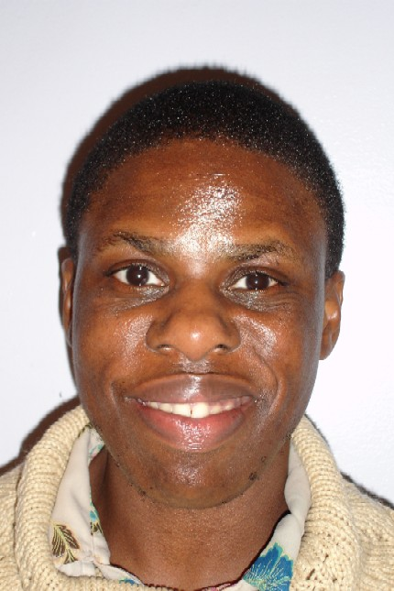  I’ve had several people asking about Jackie, wanting to know more about her, so I asked her if I could feature her in this month’s newsletter and she said ‘alright.’  Jackie is one of the service users at Queensdown Road. She has lived there for the last three years. At home she likes to help with washing the dishes, fixing tea for her and other service users, setting the table for dinner, tidying up, and doing the house grocery shopping. She also likes going to college. This year she is taking a catering and a computer course, both designed for adults with learning disabilities. The catering course runs a café on Fridays and she has really liked baking chocolate cakes and cooking pasta and chilli to sell.  Jackie is kind and welcoming. When I met her my first day at the project she shook my hands and said ‘Hello!’ several times. When she meets her classmates or the tutors in the hall before class she is sure to greet them as well. |  |  | I helped Janis, a service user, to make a chocolate cake for the first time. Below is the recipe we used, slightly adapted, from the Children’s Quick and Easy cookbook. I recommend using sweetened chocolate. We didn’t and the icing wasn’t particularly good.  Chocolate Cake  Cake:  6 oz fine dark chocolate  4 oz butter  3 Tbls water  3 eggs  5 oz sugar  3 ground almonds  2 oz all-purpose flour  pinch of salt  Icing:  4 oz fine dark chocolate  2 Tbls sour cream  Set oven for 375ºF and grease the 8” cake tin. Melt the chocolate in a bowl over a pan of simmering water. Add the butter and water and stir until the butter is melted. Separate the eggs. Whisk the yolks and sugar together until they are thick and creamy. Add yolk mixture, ground almonds and flour to the chocolate and mix well. Whisk the egg whites with the salt until they form stiff peaks. Fold them gently into the chocolate mixture. Pour into the cake tin and bake for 40-45 minutes. Cool for 5 minutes before moving to a wire rack to finish.  To make the topping, melt the chocolate as before. Remove from the heat and add the sour cream. Spread over the cooled cake. Top with flaked almonds and enjoy. You may also want to try fresh sliced strawberries.
The US of A in England  Another brilliant review of the former colonies turned superpower. I read one article a few weeks ago with the headline ‘Is This the Death of America?’ and stated such unflattering statistics as the US position at 43rd in the world infant mortality rankings, higher than Cuba and an infant born in Beijing is three times more likely to live to its third birthday than one born in the US. We have the world’s costliest healthcare and ‘37 million living under the poverty line, largely unnoticed by the richest in a country with more than three million millionaires.’  More recently, there is the number of US soldiers dead in Iraq has now surpassed 2,000 and Harriet Miers’ recindication of her nomination to the Supreme Court after Bush’s unyielding support of her. The Bush administration’s motto is seen as being that of no retreat. |  | 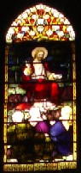  Union Chapel, Islington: Jesus and the children.  (Memorial window to Dr. Henry Allon, minister of Union Chapel 1844-92, by Lavers and Westlake, 1893.)
Kate Drefke  13 Dr Spurstowes Almhouses  36-38 Navarino Road  London  E8 1AF  United Kingdom  k.e.drefke@gmail.com  http://drefkeonamission.blogspot.com | The Young Adults in Global Mission is a program of the Evangelical Lutheran Church in America which provides adults between the ages of 19 and 30 a year of volunteer service. The program offers leadership development, spiritual growth, global awareness and understanding.  To find out more about outreach of the church, please visit http://www.elca.org/globalserve/youngadults/

